Innovation in SMART water FOUNTAIN in IoT

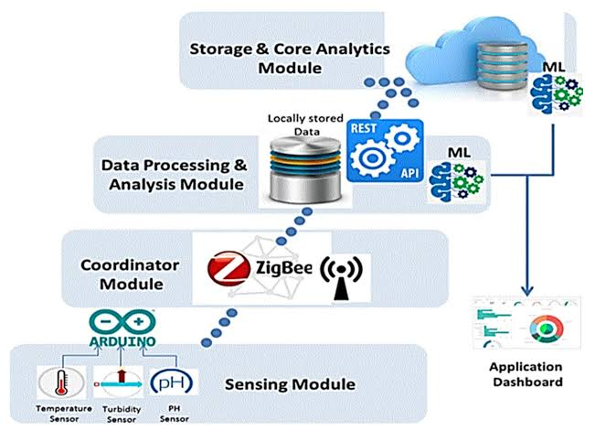

# A smart water fountain integrated with IoT technology revolutionizes traditional hydration systems. Equipped with sensors, it detects approaching individuals and dispenses water precisely upon recognition, promoting a touchless experience for improved hygiene. The IoT connectivity enables real-time monitoring of water consumption, allowing users to track their intake through a mobile app. Additionally, the fountain optimizes water usage by adjusting flow rates based on demand, contributing to sustainability efforts. Through data analytics, it offers personalized hydration recommendations, considering factors like weather, activity levels, and individual health profiles. Ultimately, this innovative IoT-powered smart water fountain enhances user convenience, promotes eco-friendliness, and encourages a healthier lifestyle.

ideas for an innovative smart water fountain in the context of the Internet of Things (IoT):

1. **Automated Water Quality Monitoring:**

Implement sensors to continuously monitor water quality, detecting impurities and adjusting filtration systems in real-time for optimal water quality.

1. **Customizable Fountain Patterns:**

Offer a mobile app interface allowing users to customize the fountain’s water patterns, colors, and intensity to suit their preferences or events.

1. **Gesture Control:**

Incorporate gesture recognition technology so users can control the fountain’s operation and settings with hand gestures, providing an interactive and futuristic experience.

1. **Water Conservation Features:**

Utilize sensors to detect the presence of people nearby and adjust the fountain’s flow accordingly, promoting water conservation during off-peak hours or when no one is around.

1. **Solar-Powered Operation:**

Integrate solar panels to power the fountain, making it energy-efficient and environmentally friendly, especially in outdoor settings.

1. **Real-time Usage Analytics:**

Capture usage data and provide analytics through a mobile app, allowing users to understand the fountain’s usage patterns and make informed decisions for maintenance and improvements.

1. **Automatic Maintenance Alerts:**

Enable the fountain to monitor its own components and send alerts for maintenance needs, helping to ensure the system remains in optimal condition.

1. **Water Recycling and Purification:**

Design the fountain to recycle and purify water within a closed loop, promoting sustainability and minimizing water wastage.

1. **Smart Water Scheduling:**

Implement a scheduling system, allowing users to set specific times for the fountain to operate, conserving energy and water during non-peak periods.

1. **Integration with Weather Data:**

Integrate with weather forecasting services to adjust the fountain’s operation based on weather conditions, optimizing water usage during dry or rainy periods.

These features collectively contribute to a smart water fountain that is efficient, interactive, and environmentally conscious, utilizing IoT technology to enhance the overall experience.